**Answers to review for Chapter 2 Test- Algebra 1**

Spiral Review

1. 10x+3
2.     
3. 91
4. 4n+4
5. C=2.10t+12
6. $201
7. $34.58

Review (Pre-test)

1. 120 students were surveyed
2. 29blue eyed students/120 total students or

29blue eyed students: 120 total students or

29 blue eyed students to 120 total students

1. 18 brown-eyed students in 9th grade/65 total brown eyed students or

18 brown-eyed students in 9th grade:65 total brown eyed students

18 brown-eyed students in 9th grade to 65 total brown eyed students

1. 24
2. 13
3. X=1206
4. X=72
5. 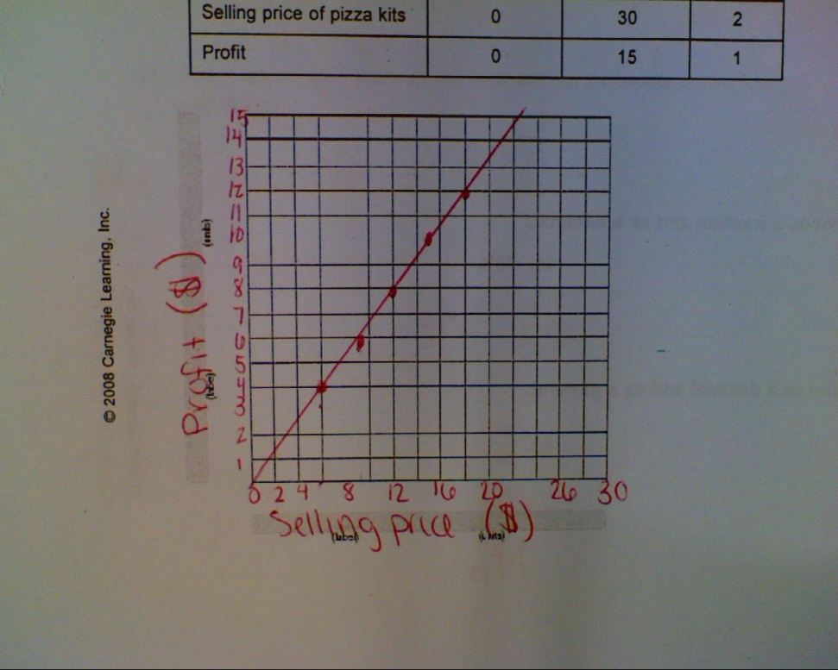2 drops of red to 5 total drops
6. (get common demominator), 1/3, 5/9, ¾
7. 160 meters/min
8. The length of EF is 16 meters.
9. 3960 feet is equal to 0.75 (or ¾) miles
10. See picture on side. You must go up by what I

went up by since that was in the instructions.

1. 
2. A pizza kit sold at $24 will yield a profit of $16
3. 
4. 3/10 and 0.3
5. 39/50 and 0.78
6. 0.29 and 29%
7. 0.74 and 74%
8. If your bill is $36, you will leave $5.40 for a tip.
9. If your gross pay is $450, you will pay $135 in taxes.
10. Your tax rate is 30%